Checklist for Evaluating Web Resources

A Visual Guide to Evaluating Sources on the Web

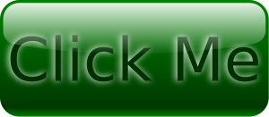
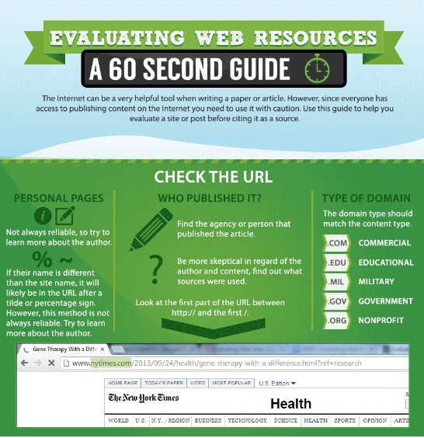
Is the Web a good research tool? This question is dependent on the researcher's objective. As in traditional print resources one must use a method of critical analysis to determine its value. Here is a checklist for evaluating web resources to help in that determination.

Authority:
Is the information reliable?
Check the author's credentials and affiliation. Is the author an expert in the field?
Does the resource have a reputable organization or expert behind it?
Are the sources of information stated? Can you verify the information?
Can the author be contacted for clarification?
Check for organizational or author biases.
Scope:
Is the material at this site useful, unique, accurate or is it derivative, repetitious, or doubtful?
Is the information available in other formats?
Is the purpose of the resource clearly stated? Does it fulfill its purpose?
What items are included in the resource? What subject area, time period, formats or types of material are covered?
Is the information factual or opinion?
Does the site contain original information or simply links?
How frequently is the resource updated?
Does the site have clear and obvious pointers to new content?
Format and Presentation:
Is the information easy to get to? How many links does it take to get to something useful?
What is the quality of the graphical images? Do these images enhance the resource or distract from the content?
Is the target audience or intended users clearly indicated?
Is the arrangement of links uncluttered?
Does the site have its own search engine?
Is the site easily browsable or searchable?
Cost and Accessibility:
Is the site available on a consistent basis?
Is response time fast?
Does the site have a text-based alternative?
How many links lead to a dead-end?
Is this a fee-based site? Can non-members still have access to part of the site?
Must you register a name and password before using the site?
Other Tips:
Check the header and footer information to determine the author and source.
In the URL, a tilde ~ usually indicated a personal web directory rather than being part of the organization's official web site.
In order to verify an author's credentials, you may need to consult some printed sources such as Who's Who in America or the Biography Index.
Check and compare the web site to others which are both similar and different.

 | Criteria | Rationale | How Can I Tell?
Authority | - Is the page signed?  - Are the author's qualifications available?  - Does s/he have expertise in this subject?  - Is the author associated with an educational institution or other reputable organization?  - Does the publisher or publication have a reputation for reliability?  - Is contact information for the author or group available on the site? | - It's often hard to determine a web page's authorship.  - Unlike traditional print resources, Web resources rarely have editors or fact-checkers.  - There are no standards for information on the web which would ensure that all information there is accurate and useful.  - People create web pages for different reasons:  - Personal  - Advocacy  - Commercial/Marketing  - Informational | - Look at the top and bottom of the web page for clues.  - Use the WhoIs service to determine the page's owner.  - Is there a link to a main web site for the group/educational institution/ organization hosting this web page?  - Does the author or host have a web page explaining who they are and what their mission or philosophy is?  - Ask a Librarian if information about the publisher is available
Now consider this web page

Coverage | - Is the information even relevant to your topic?  - Do you think it is useful to you?  - Does this page have information that is not found elsewhere?  - How in-depth is the material? | - Web coverage often differs from print/ scholarly coverage.  - Frequently it's difficult to determine the extent of coverage.  - Sometimes web information is just-for-fun or outright silliness. | - Read through/scan the web page and consider.  - Ask a Librarian if the information you have found can be verified elsewhere.
Now consider this web page
Objectivity | - Does the information show a minimum of bias?  - Is the page a presentation of facts and not designed to sway opinion?  - Is the page free of advertisements or sponsored links? | - Frequently the goals of the sponsors/authors aren't clearly stated.  - Often the web serves as a virtual soapbox where people express their opinions.  - The content of the page may be influenced by the advertiser. | - Read through/scan the web page and consider.  - Does the author or host have a web page explaining who they are and what their mission or philosophy is?  - See what other websites link to the site in question. Google's link searches is one method.  - Ask a Librarian if information about the author/ company/ organization is available.
Now consider this web page
Accuracy | - Is the information reliable and error-free?  - Can you find when was the last update?  - Is there an editor or someone who verifies/checks the information?  - Is the page free of spelling mistakes or other obvious problems? | - Anyone can publish anythingon the Web.  - Unlike traditional print/scholarly resources, Web resources rarely have editors or fact-checkers.  - Currently, no Web standards exist to ensure accuracy. | - Read through/scan the Web page and consider.  - Confirm the information/data with other sources.  - Ask a Librarian if the information you have found can be verified elsewhere.
Now consider this web page
Currency | - Is the page dated?  - Can you find when was the last update?  - Are the links current and do they point to existing pages? | - Publication or revision dates are not always provided.  - Pages with broken links may not be updated regularly.  - If a date is provided, it may have various meanings. For example it may indicate when the material:  - was first written  - was first placed on the Web  - was last updated | - Read through and scan the text to see if the author attributes information/facts to a particular year. e.g. "in 1997, 35 car accidents were caused by chickens crossing the road."  - Scan through the bibliography or list of references (be concerned if there isn't one!) and see how current each item is. e.g. Cool, Joe. (1975) "Current flying practices." Canine Aviation 32(3):23-40.  - Look at the footer to see if the author has included a date.
Now consider this web page

1- Scan the URL
The URL is the web address of the page you are reading. it has this format :www.name of the website.name of article you are reading.com. This is the first door we need to tap in to get a glimpse of what the article is all about. Read the URL carefully and look for the following :

Does the URL have a domain name and if so is it appropriate for the content ? Students should know that a site that has a domain name ending with .edu is more likely to be relevant for academic and educational content. Other domain names of interest are .com, , .gov, .org. This does not mean that other domain names are spam or would not be irrelevant, we can also find good and credible content in other domains.
2- When you are on a web page, make sure you check for these : " about us", " Philosophy ", " Background", " Bibliography". This will give you an idea about the people behind that content.
3- Look for the name of the author, or the name of the organization or institution, agency or whoever is responsible for the page.
4- Check out if the page is dated and if so , is it current enough ? Undated factual or statistical information is no better than anonymous information.
5- Look for indicators of quality information: are sources documented with footnotes or links? Do the links work? Are they reliable? If the article is reproduced from another source then is it complete, not altered, fake, or forged?
6- Try to figure out the purpose of the website? Is it mainly commercial? is the author trying to generate revenue by recommending things, enticing, or selling products ? Is the website informative and provides data and facts?

Evaluation Criteria
According to nmsu.edu, There are 5 major yardsticks to keep in mind while trying to evaluate a website:
1- Authority : The authority of a webpage can be established by finding answers to these questions :
- Is there an author? If so, is there a way to contact him/her?
- Is the page signed?
- Is the author qualified? An expert in his domain? (you can learn about this from his " about us " page if he has one.
- Is there a link to the information about the author or the sponsor of the website? If the pages does not include no author name of sponsor, then is there any other way to determine its origin?
2- Accuracy To establish accuracy in a web page you need to ask yourself these questions:
- Is the information reliable?
- Is it error-free?
- Does it include links to other resources?
- Is there an editor or someone who verifies and checks information?
3- Objectivity :To look for objectivity in a web page you need to ask the following questions :
- Does the information show a minimum of bias?
- Is the author impartial in his reasoning?
- Is the page designed to sway opinions?
- How much advertising on the page?
4- CurrencyTo investigate about this feature ask the following:
- Is the page dated?
- How often is it dated?
- What is the last time the page updated?
- How current are the links? Have some expired or moved?
5- Coverage : to learn about a web page coverage you need to ask the following questions :
- What topics this website cover ?
- What is it that this page offers to readers?
- How in-depth is the material?
- What about the writing style, arguments, data, and facts included? How are these developed ? "

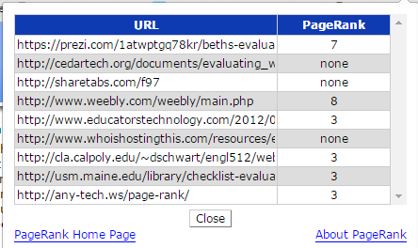
Two Great tools to evaluate websites
2- Google Page Rank
This is a sophisticated algorithm Google uses to classify websites from 0 to 10 with 10 being the top. Any webpage with a Google Page rank of 3 upwards is a website that has more chances of being credible. The first thing you should do whenever you land on a page for the first time is to check its Google Page rank. You can install its extension on your browser and with one click you will be able to see the rank number of any web page. Check this page to download the extension for Chrome, Firefox,or Safari
3- Alexa Traffic rank
Alexa traffic rank is another great tool to rank websites. Advertisers use it a lot especially when looking for potential clients. Alexa ranks websites according to their backlinks and page views. It starts with 26 million down to 1 with 1 being the top. Any website ranked from 300.000 has more chances of being a good resource. Again Alexa has an extension for both Chrome and Firefox and it can also be used right from their homepage.

